Review Center Comments Revision Report Installation Instructions

Go to Admin > Reports. Click Add Report.

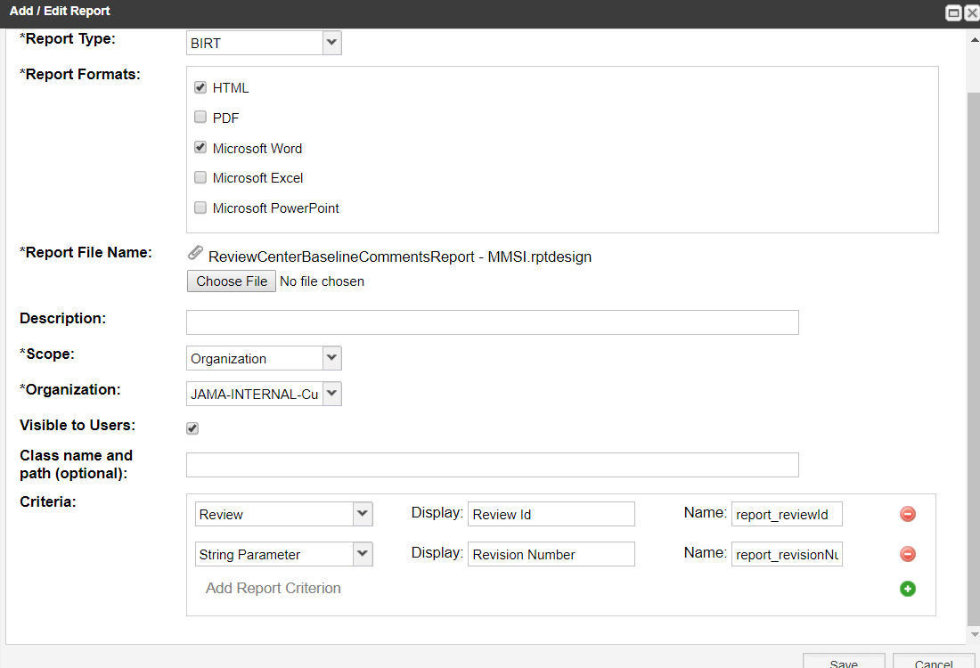

report_reviewId

report_revisionNumber